Maternal and Child Health Council Data Review and Sensemaking

Women and Maternal Group
Date: 1/11/23 Recorder:

Participants:

NOM 24: Percentage of Women with Postpartum Depressive Symptoms After Live Birth

Evaluation Question(s) Addressed
- What is the pattern in percentage of women with postpartum depressive symptoms after live birth?
- What factors or conditions may have contributed to this pattern?

Specific Graph/Evaluation Data Reviewed
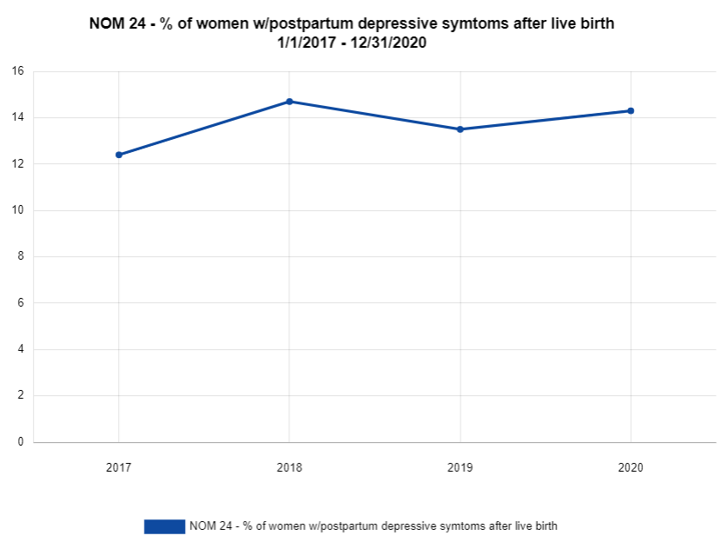
- What are we seeing in the data [e.g., What was the pattern in percentage of women with postpartum depressive symptoms after live birth? Where were there increases in levels? Decreases? What pattern did the group intend/expect, and did they meet it?]:
- Indicate where higher levels, and what was associated:
- Indicate where lower levels, and what was associated:
- Indicate whether this was the pattern the group intended/expected:

What it means: [What factors were associated with increased/higher levels?; What factors were associated with decreased/lower levels?]
- Factors associated with increased/higher levels:

- Factors associated with decreased/lower levels:

Implications for adjustment:
[What adjustments (if any) should we make to improve activities and outcomes?]:
- Indicate adjustments the group should/will make to improve activities and outcomes

--ACTION PLAN for Improvement (indicate goal): Align data/ data sources.
WHAT will be done | BY WHOM | BY WHEN | RESOURCES NEEDED

